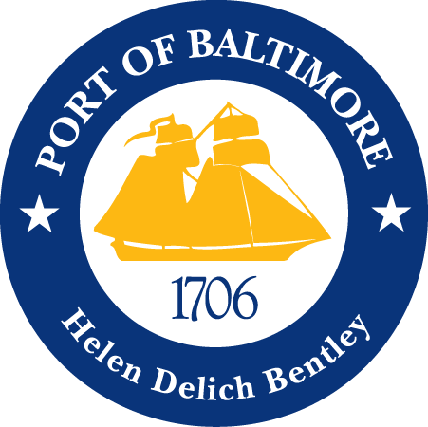

2018 AAPA COMMUNICATION AWARDS SUBMISSION
Port of Baltimore
Holiday Card
Classification 13: Video
Port Category: 2
Summary:
The Maryland Port Administration (MPA) made the decision to craft a nondenominational animated e-holiday card to be distributed in the winter of 2017. We wanted it to be tasteful in showcasing our commodities and to ensure we did not show favoritism towards one particular holiday. The Communications team used Adobe After Effects to create our holiday card.
1. What are/ were the entry’s specific communications challenges or opportunities?
As a state agency, one of the biggest challenges we face is budget constraints. While the MPA has direct control over its six public terminals, it is also responsible for promoting and communicating on behalf of all public and private marine terminals located in Baltimore as the “Port of Baltimore”. In previous years, the MPA outsourced for our animated holiday cards. This year, our in-house graphic designer was trained on specific software to create this e-card. The learning curve was a bit of a hurdle but through teamwork, communication and time, we delivered a beautiful finalized product.
2. How does the communication used in this entry complement the organization’s overall mission?
The mission of the MPA is to increase waterborne commerce throughout the POB to benefit the citizens of State of Maryland. At the heart of our mission statement is stellar customer service; we are completely a service based industry. It is important that our customers feel appreciated and are happy with the business they do with us. The holiday card is a small token of appreciation for all that our customers do for the Baltimore community, the Port and the MPA.
3. What were the communications planning and programming components used for this entry?
The audience for the holiday card is customers of the Port of Baltimore and the MPA.
The goals of the video were to:
- Show appreciation to our customers for working with the Port of Baltimore.
- To wish our customers happy holidays.
- To design an aesthetically pleasing piece to share with our customers.
The objective of this video was to:
- Conceptualize, design, and create a holiday card.
- The milestones to achieve our objective was:
  - Determine audience
  - Select music and images
  - Import the selected music and images into Adobe After Effects.
  - Create the desired piece
  - Export and distribute the final product to our customers.
4. What actions were taken and what communication outputs were employed in this entry?
As a state agency, we are allocated a limited amount of advertising dollars each fiscal year, and those funds are always subject to budget cuts due to the state’s budget constraints. The MPA previously outsourced our animated holiday cards creation to a third party, but as a cost saving measure the in-house graphic designer created our animated e-card for 2017. Through the use of Adobe After Effects and various other resources, our internal collaborative efforts with Communications and the Executive office, the MPA created an animated e-card that we are very proud of. The 2017 holiday e-card was distributed via email in December.
5. What were the communications outcomes from this entry and what evaluation methods were used to assess them?
The communication outcome for the 2017 holiday card was from this entry was incredibly positive. The feedback was delivered by word of mouth or via email. Most of our customers reached out to say they loved the card and that they felt very appreciated by our efforts.

